**Дата**: 17.04.2025

**Клас**: 5-АБ

**Предмет**: англійська мова

**Тема:** Місце де я живу.

**Мета:** формувати навички вживання лексичних одиниць по темі; удосконалювати навички читання, аудіювання й усного монологічного мовлення; розвивати пізнавальні інтереси учнів; виховувати інтерес до самостійного пошуку потрібної інформації, а також загальну культуру учнів.

**Вчитель**: Руда Д.В.

Хід уроку

1.Greeting

Good afternoon, guys! I’m pickled pink to see you. Are you ready to start our lesson? All set?

2. Повторення

Повторити Irregular verbs .

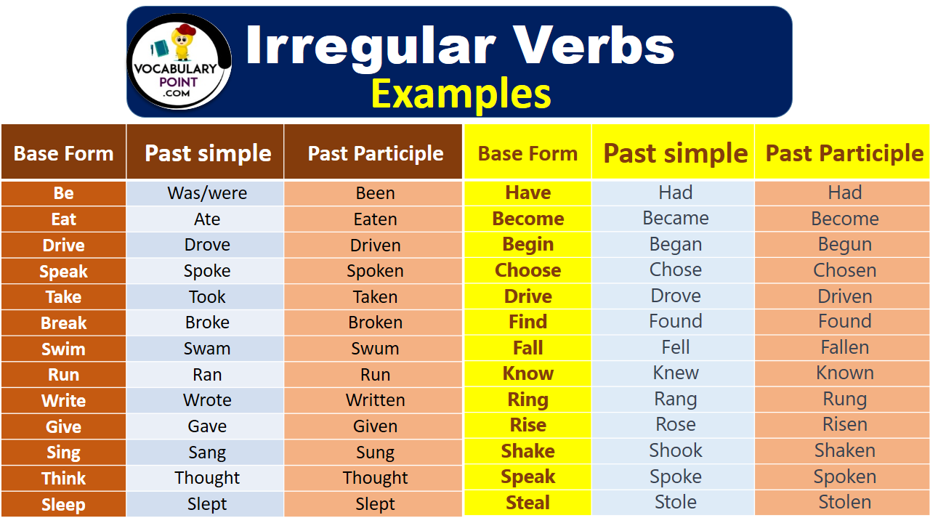

***Вивчити словник (бути готовим до слоникового диктанту) :***

*Careful-обережно (кеафул)*

*Slippery-слизько (сліпері)*

*To put on- одягати (пут он)*

*Overcast: covered with clouds; no sun is visible.- похмуро, сонця нема (овекаст)*

*"Under the weather": feeling ill or in low spirits. (e.g., "I'm feeling a bit under the weather today, so I'll stay home from work.")- мати погане самопочуття ( анде за везе)*

.

*Drizzle-мряка(дрізл)*

*Showers- a [short](https://dictionary.cambridge.org/dictionary/english/short" \o "short) [period](https://dictionary.cambridge.org/dictionary/english/period" \o "period) of [rain](https://dictionary.cambridge.org/dictionary/english/rain" \o "rain) or [snow](https://dictionary.cambridge.org/dictionary/english/snow" \o "snow)*

*Downpour- a lot of [rain](https://dictionary.cambridge.org/dictionary/english/rain" \o "rain) in a [short](https://dictionary.cambridge.org/dictionary/english/short" \o "short) [time](https://dictionary.cambridge.org/dictionary/english/time" \o "time) (дайн пор)*

*Flood-повінь(флад)*

*Hail-град(хейл)*

*Sleet-мокрий сніг(сліт)*

*Snowflake-сніжинка(сноуфлейк)*

*Blizzard-хуртелиця (блізард)*

*Mild: moderate in temperature; neither hot nor cold- помірний, м’який (майлд)*

*"Every cloud has a silver lining": every bad situation has some positive aspect to it. (e.g., "I lost my job, but I found a better one soon after. Every cloud has a silver lining.")- нема лиха без добра( ідіома)*

*To expect-очікувати(експект)*

*To report-повідомити(ріпот)*

*Chilly-прохолодний(чілі)*

*To get cold-холоднішати*

*It`s raining cats and dogs-сильно дощити (ідіома)*

*They cancelled the football game because it was raining cats and dogs.*

3. Wаrm up / Listening

Уважно слухати аудіо трек і дати відповідь на питання вчителя .

4. Speaking

Do you like your hometown? Why or why not?

How many TV channels do you get at home?

Do you miss your home country?

What do you miss the most?

Do your childhood friends still live in your hometown?

If not, where are they now?

Does anyone famous come from your hometown?

Does your hometown have any festivals? What happens at that festival?

How long does it take to get from your hometown to here?

Has your hometown changed a lot since you were a kid? If so, how? Have the changes been for the better or worse?

Is your hometown famous for anything?

Where is your hometown?

What is the population of your hometown?

What is the population of your country?

What are some things in your hometown that are part of history?

What does your hometown produce? What does it grow?

What is the best season in your hometown?

What is the best thing about your hometown?

What is the worst thing about your hometown?

What's there to do in your hometown?

What's your hometown like?

When is the best time to come to your hometown?

Where are you from?

What is the geography of your hometown? (i.e. beach, mountains, etc.)

What are the main attractions in your hometown?

What are the main economical resources in your hometown?

Can you describe the main geographical features of your hometown?

What is the average temperature in winter time? (summer time?)

Would you like to be in your hometown now? Why or why not?

If you could live anywhere, where would you like to live?

Tell me why I would enjoy visiting your hometown.

5. Writing

Повторити граматику (past simple/present perfect).

<https://www.liveworksheets.com/w/en/english-second-language-esl/2116124>

<https://www.liveworksheets.com/w/en/english-second-language-esl/616043>

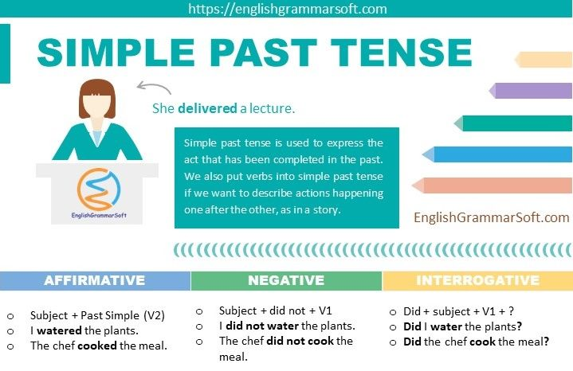

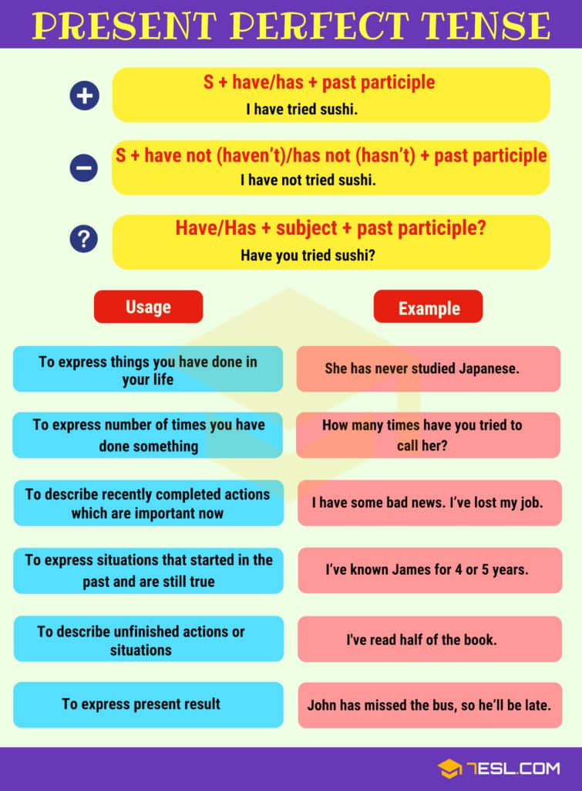

<https://wordwall.net/ru/resource/73407780/%d0%b0%d0%bd%d0%b3%d0%bb%d0%b8%d0%b9%d1%81%d0%ba%d0%b8%d0%b9/present-perfect-vs-past-simple-by-ms-eugenia>

<https://wordwall.net/ru/resource/72608600/english/present-perfect-vs-past-simple>

<https://wordwall.net/ru/resource/73487453/english/presentperfect-vs-pastsimple>

6. Homework

1. Виконати вправу 2 стр 119 у підручнику.

2. Вивчити слова на стр 115 у підручнику.